# Detailed Instruction Manual: Installing Python 3.8.2 on Windows

## Prerequisites:

Before you start the installation process, make sure you have administrative privileges on your Windows system. Also, ensure you have a stable internet connection.

## Step 1: Download Python 3.8.2

1. Double click Python 3.8.2 installer to install python
2. Select add Python 3.8 to path
3. Select customize installation 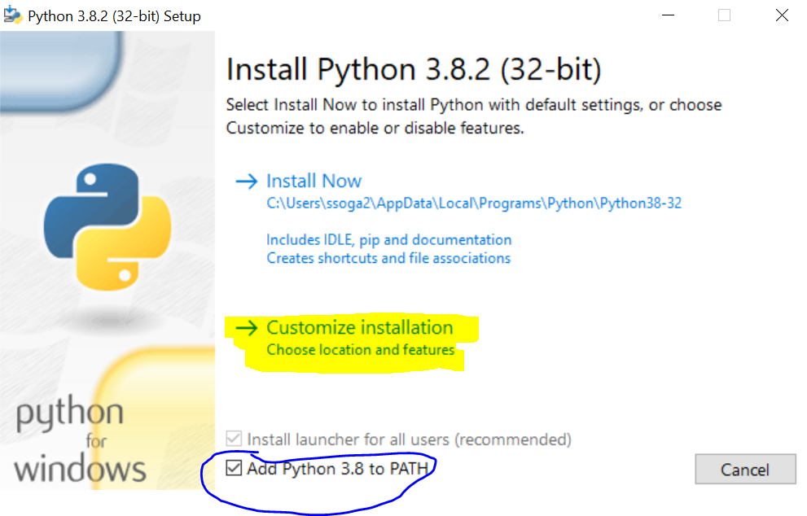
4. Now select the following options 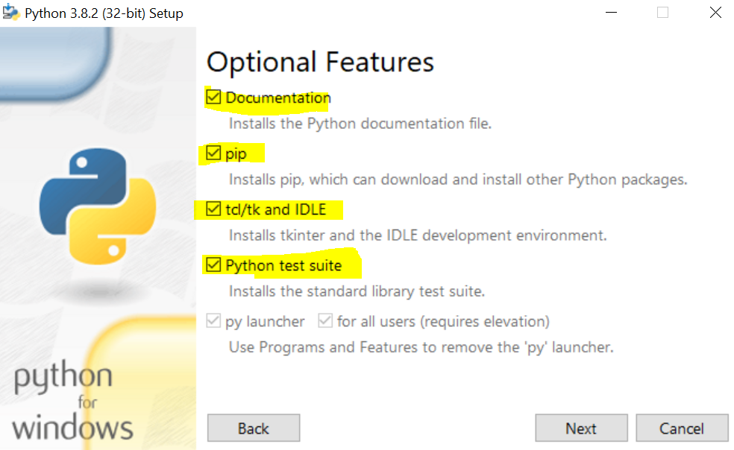
5. Select Next and make sure install for all users is deselected

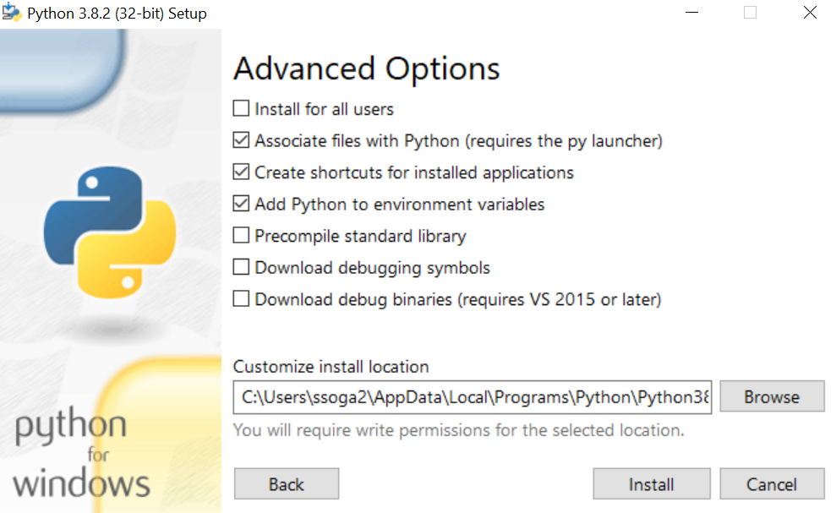

1. Now hit install

## Step 2:

# Guided Instructions: Installing Pygame 1.9.6 for Python 3.8.2 on Windows via PowerShell

## Step 1: Download Pygame Wheel File

1. from the provided One Drive link download pygame-1.9.6-cp38-cp38-win32.whl

3. Right-click on the downloaded file and copy the location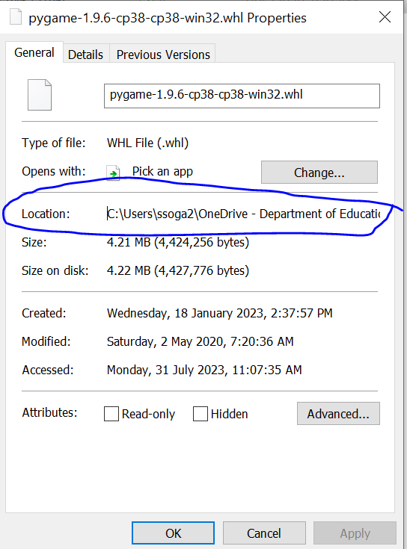

## Step 2: Open PowerShell

1. Click on the Windows Start menu and search for "PowerShell."

2. Right-click on "Windows PowerShell" and choose "Run as administrator."

3. Click "Yes" if prompted by the User Account Control (UAC) dialog.

## Step 3: Navigate to the Download Directory

1. By default, PowerShell opens in the user's home directory. To navigate to the Downloads folder (or any other location where you downloaded the Pygame wheel file):

Type the following command and press Enter:

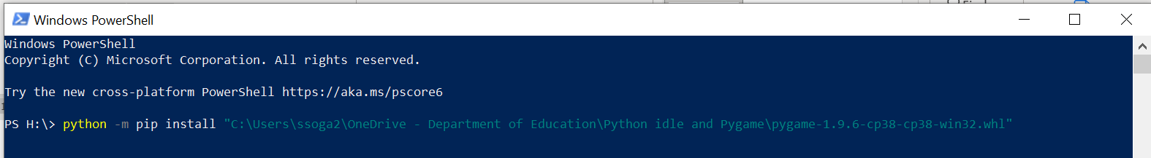

Python -m pip install “ location of the file\ pygame-1.9.6-cp38-cp38-win32.whl “

And press enter

You will be prompted that the installation was successful

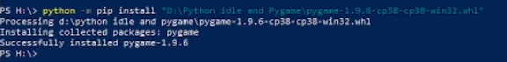

To check open python by searching idle select idle

Type in import pygame in the shell window and you will see the following message if pygame is successfully installed

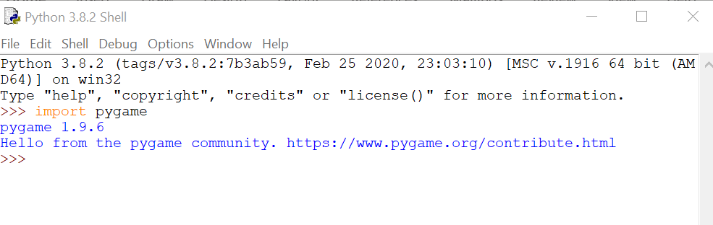

Now you are ready to build your first epic game!